



Reception Class

Information for Parents/Carers

September 2018

# Welcome

#### The staff would like to extend a warm welcome to all the pupils and parents who come to Magdalene House Preparatory School, which is part of the long-established Wisbech Grammar School.

#### This Handbook provides information to help you and your family find out more about the School. However, communication is vital to the Home-School partnership from the outset, so please do contact the School at [pupilservices@wisbechgrammar.com](mailto:pupilservices@wisbechgrammar.com%20) if you have any questions, concerns or queries. There is also more information available on the School website.

**Mrs Keryn Neaves B.Ed Teacher’s Dip, Senior Deputy Head Magdalee House**

## The School

At Magdalene House Preparatory School we intend to provide your children with a wide range of educational opportunities within a family atmosphere inspired by our Christian foundation. We believe that every individual has a contribution to make and this helps to create the special environment of our School, where each child is known and valued.

## Aims of the School

* To ensure that the children feel happy, confident and safe in the School environment.
* To help in the development of well-balanced, independent children.
* To foster tolerance and respect for the differences in each other.
* To improve listening skills and encourage the children to develop greater self-discipline.
* To celebrate the uniqueness and dignity of each individual.
* To provide the foundations for all future learning through a range of activities.

Children’s development and enjoyment of learning in the Early Years is encouraged and stimulated through a variety of different activities in a secure indoor and outdoor environment, through play, structured learning opportunities and creative activities. The relationships which children develop with each other and with our staff at this stage are central to their happiness and lay the best possible foundation for their future.

All parents of children in the Reception class are invited to a presentation, during the preceding Trinity term, about the EYFS curriculum, and daily routines in the Reception class will be explained.

Table of Contents

Welcome 2

The School 2

Aims of the School 2

Policies 5

Magdalene House Staff 2018-2019 6

Senior Staff 6

Teaching Staff 6

Wisbech Grammar School Specialist Teaching Staff 6

Reception Class Staff 7

Teaching Assistants 7

Learning Support Assistants 8

Administration Staff 8

Lunchtime Supervisors 8

Contacting School 8

Pupil Services 8

Chair of Governors 8

The School Day 9

Bringing and Collecting Your Child 10

Arrival at School 10

Initial Settling In 10

Arriving Late 10

Collecting Children after School 10

Procedures When a Child is Not Collected on Time 11

Procedures in the Event of a Child going Missing 11

Foundation Stage Curriculum 12

Prime Areas: 12

Specific Areas: 12

Teaching and Learning 12

Outdoor Learning 13

Homework Diary 14

Clubs 14

Food and Drink 15

School Lunches / Snacks / Drinks 15

Special Diets 15

Assemblies 16

Reward Systems 16

The House System 16

Code of Conduct 17

Visits 18

Keeping in Touch 19

Parents’ Evenings 19

EYFS Profile Progress and Reports 20

Communication 20

Absence due to Illness 20

Planned Absence 21

Medical Matters 21

First Aid 22

Pupils who are Injured or Infectious 22

Emergency Medical Treatment 22

Medicines and Treatments Brought to School for Pupils 22

Immunisations 22

School Medication Policy 23

Maintaining a Safe and Secure Environment 24

On-Site Health and Safety 24

Admissions 24

Children with Medical or Special Educational Needs who require special adjustments 26

English as an Additional Language 26

Equal Opportunities Policy 26

Safeguarding/Child Protection 27

E-Safety 27

Use of Camera and Recording Equipment in EYFS 27

Concerns and Complaints 28

Storage of Records 28

Parking 28

Uniform 29

Stationery Requirements 29

(Reception pupils) 29

(Prep 1 and 2 pupils) 29

In Conclusion 30

Contact Us 30

Accounts Queries 30

Admissions Enquiries 30

The contents of this Handbook are as accurate as they can be at the time of writing but may be subject to change as the needs of the School vary.

Parents are advised to check with the School the accuracy of any detail which is of particular importance to them or to their child.

# Policies

Available on the Wisbech Grammar School Website that relate to Magdalene House specifically:

Admissions Policy (A1)

SEND Policy (A2)

Curriculum Policy (A3)

Anti-Bullying Policy (A4)

Good Behaviour Policy (A4)

PSHCE Policy (A5)

Safeguarding Policy (A6)

e-Safety Policy (A5)

Health and Safety Policy (A9)

Risk Assessment Policy (A10)

Fire Safety Policy (A11)

Supervision Policy (A12)

Complaints Policy (A14)

SEND 3-Year Accessibility Policy (A15)

Whole School and Magdalene House Preparatory School policies are available on the Wisbech Grammar School website: **wisbechgrammar.com**

Or on request from School directly at:  [**pupilservices@wisbechgrammar.com**](mailto:office@wisbechgrammar.com)

# Magdalene House Staff 2018-2019

## Senior Staff

Mrs K Neaves B.Ed Teacher’s Dip Senior Deputy Head Magdalene House

Mrs K Fairbrother B.Ed (Hons) Assistant Deputy Head, Prep 4 Teacher

Mrs T Crawley B.Ed (Hons), MEd Leader of Teaching and Learning, Prep 3 Teacher

## Teaching Staff

Mrs A Beck BA, PGCE Prep 6 Teacher

Mrs K Cook, BA MA PGCE Prep 2 Teacher

Mrs E J Fenn BA (Hons) Support Teacher

Miss M Gillings NCFE L3 Teaching Assistant EYFS Practitioner

Mrs C Harding PG Dip, AMBD Learning Support and Piano/Saxophone/Oboe Teacher GRSM, ARCM

Mr D M Hyland BA (Hons) MA Prep 5 Teacher (2 days)

Mrs A Kelly BA (Hons) Prep 6 Teacher

Mrs G McMullen BA (Hons) Support Teacher

Mrs E Oram BA, PGCE (Hons) EYFS Lead

Mrs J Page B Ed (Hons) Prep 5 Teacher

Mrs C Sandall BA (Hons) Prep 5 Teacher (3 days)

Miss A Thorpe CACHE L4 NVQ, CACHE L3 EYFS Practitioner

Mrs J Whiteman CertEd Prep 1 Teacher

## Wisbech Grammar School Specialist Teaching Staff

Mr M Arnold Prep 5 and 6 Computing

Mrs S Duncan BSc Performing Arts

Mrs S Fox BA, MSc Prep 5 and 6 Science

Mrs S M Goodier BSc PE and Sport

Mr T Jestin MA French

Mr A C Laybourne MSc PE and Sport

Mrs J Missin BA Music

Mr I Rodriguez BA Spanish

Mrs M Skinner German

Mrs A Sloan BSc MA Prep 5 & 6 Food & Nutrition

Mr N Taylor PE and Sport

Mrs M Tooke BSc Prep 3 & 4 Food & Nutrition

Mr P J Webb BA Director of Sport

Mr F Whatling PE and Sport

Mr J D Williams PE and Sport

## Reception Class Staff

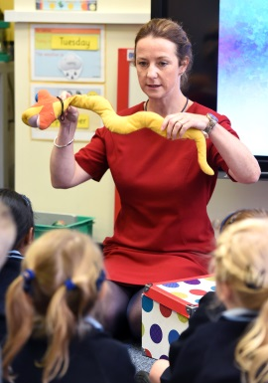Mrs Oram, an experienced teacher, is in charge of Reception Class with day-to-day responsibility for all of its activities. In addition, an NVQ L3 qualified Early Years practitioner will support the class. Overall responsibility for Reception lays with Mrs Neaves, Senior Deputy Head, Magdalene House. The children are supervised by qualified staff at all times when they are under our care, including break, lunch and play times.

## Teaching Assistants

Mrs V Andrews (NCFE Teaching Assistant Level 2, CACHE Level 3, BTEC National Diploma in Childhood Studies)

Mrs L Barnes (NCFE Teaching Assistant Level 2)

Mrs S Boughen (City and Guilds in Community Care)

Mrs L Field

Ms H French (NVQ Level 3)

Mrs L Gray (BTEC in Nursery Nursing)

Mrs S Peck (NCFE Teaching Assistant Level 2, NVQ Level 3)

Mrs S Porter

Mrs S J Webb (NVQ Level 3, BTEC National Diploma in Sport)

## Learning Support Assistants

Mrs C Ayling

Level 3 Diploma in Specialist Support for Teaching and Learning in Schools QCF. ELKLAN Speech and Language Trainers, Level 2 Teaching and Learning Success at Arithmetic, Spelling and Phonics

Mr F Whatling

Level 2 BTEC First Diploma in Public Services, currently undertaking NVQ Level 3 in Children’s Learning and Development

Mrs M Peukert

## Administration Staff

Mrs S A Davies PA to Senior Deputy Head / Pupil Services

## Lunchtime Supervisors

Mrs P Aldrich

Mrs L Field

Mrs C Hunt

Mrs Michelle Peukert

# Contacting School

Teaching staff and the Senior Deputy Head at Magdalene House are normally available before the start and at the end of the School day dependent on duty, meeting and club commitments.

A Receptionist is in school during term time from 07:45 until 17:30. If you need to contact the School during holiday periods, a Receptionist is usually available from 09.00 until 16:00.

## Pupil Services

Phone: 01945 586780 or 01945 583631

Email: [pupilservices@wisbechgrammar.com](mailto:office@magdalenehouseprep.com)

## Chair of Governors

The Chair of the Governors is Dr D Barter, MB, BS, FRCP, FRCPCH, DCH.

He can be contacted via Wisbech Grammar School, Chapel Road, Wisbech, Cambridgeshire, PE13 1RH.

# The School Day

07.45 Breakfast Club

08.00 Playground Supervision commences

08.40 Registration/ Period One

09.35 Period Two

10.25 Break

10.45 Period Three

11.40 LUNCH

12.40 Period Four

13.15 Period Five

14.05 Break

14.25 Period Six

15.30 End of School

Period Seven - Activities

16.10 End of Activities

Break

16.30 Homework Club

17.30 School Closes

A Breakfast Club is also available in the Skelton Hall from 07.45 – 08.20 (see website for details) Pupils must be brought to the Main Reception area to sign in

# Bringing and Collecting Your Child

## Arrival at School

Pupils may arrive from 08.00 onwards (unless attending Breakfast Club) when staff will be on duty in the playground. Whistle and line up is at 08.40. Registration is at 08.45 followed by lessons.

In the mornings, please park in the main School carpark off Chapel Road and take your child/ren to the coloured gates to the right of Magdalene House where a member of staff will receive them.

Alternatively, if you arrive via the ‘Hudson’ entrance pupils will be received via the gate in the ‘Pirate Ship’ playground.

If it is raining, the children will be sent by the staff on duty to the Alan Salmon Hall.

## Initial Settling In

For the children to feel welcome and not so overwhelmed during their first few days, we invite them to have a shortened day commencing at 09.00 when they will be met by Mrs Oram at the coloured side gate. You can then collect them at 15.00 from the same place.

## Arriving Late

Any children arriving after Registration time should be taken via the main Magdalene House entrance to the Receptionist, who will register the child and take or send him/her to class.

Reasons must be given for lateness and the ‘Late Book’ signed. The child will be marked ‘late’ in the register.

## Collecting Children after School

15.30 – Pupils can be collected from the coloured gates by a Parent or Guardian.

16.10 – Pupils can be collected from the coloured gates by a Parent or Guardian.

17.30 – Pupils can be collected Pupil Services by a Parent or Guardian.

Magdalene House children may be collected by an older sibling/pupil from the Senior School, but the School must have received written permission from a Parent or Guardian stating that the child will go with that person straight to a supervising adult.

If a child is to be regularly collected by anyone other than the parent/carer, written details of the arrangement should be sent to School at the beginning of term on the appropriate form (this may be obtained from Pupil Services. Any other arrangement for the collection of children during the term must be put in writing to the School 24 hours BEFORE the date/time required.

## Procedures When a Child is Not Collected on Time

If for any reason the person collecting the children is delayed, they should inform the School via Pupil Services as soon as possible. Any pupils who cannot be collected as a result of the delay will be supervised by a member of staff for as long as necessary.

## Procedures in the Event of a Child going Missing

In the unlikely event that a child is lost, or goes missing, the parents/carers and relevant authorities will be informed. The grounds and buildings would be searched and checks made. The ‘Missing Child’ policy explains procedures if such an event were to occur.

# Foundation Stage Curriculum

At Magdalene House Preparatory School we offer a broad and balanced Foundation Stage curriculum for our youngest pupils based upon the (Sept. 2012 Revised) Development Matters EYFS Curriculum. All children are given equal access and opportunities to develop their knowledge and skills in the areas listed below:

## Prime Areas:

* Personal, Social and Emotional Development
* Communication and Language
* Physical Development

## Specific Areas:

* Literacy
* Mathematics
* Understanding of the World
* Expressive Arts and Design

## Teaching and Learning

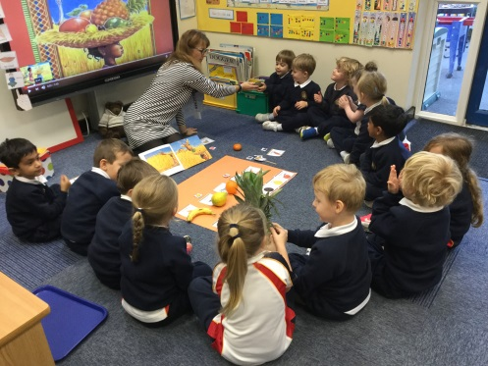All children learn through play with a mixture of child initiated and Teacher-led learning opportunities. Learning takes place both indoors and outdoors.

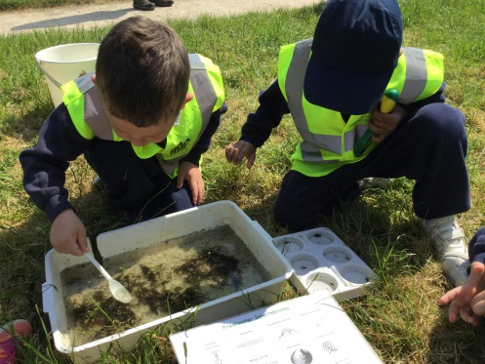In the Reception class, all areas are taught through a topic-based curriculum. We gradually introduce phonics through the Letters and Sounds Primary National Strategy, and the basics of literacy are taught daily through a varied reading scheme. Children are gradually introduced to the principles of writing. Mathematics is taught daily using different practical activities such as counting, weighing and measuring. All children are encouraged to participate in Dance, Games, Music, Modern Foreign Languages and Computing across the curriculum. By the end of Reception, the children are enthusiastic and confident learners who are ready and able to embrace the more structured, less play-based environment of Prep 1.

## Outdoor Learning

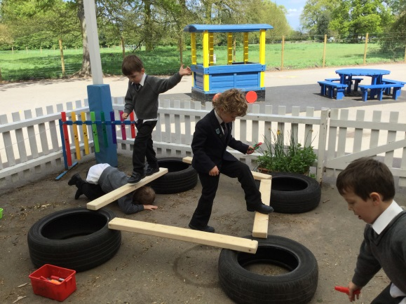All of the Reception children are encouraged to play in a secure outdoor space during morning and afternoon breaks, except in the very worst weather when they use the Alan Salmon Hall or their classroom. We have a dedicated covered canopy area that is accessed from the Reception classroom; this is being developed to cater for a wide variety of outdoor activities linked to the EYFS curriculum. We use the open ‘triangle’ playground area for supervised activities, including playing with the large outdoor play equipment such as the tricycles and scooters as well as various ball games.

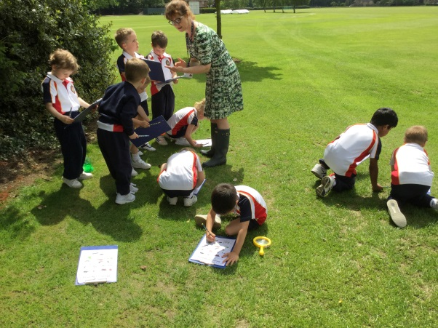In addition the children are regularly taken in supervised groups around the School grounds to learn about the seasons of the year, by collecting autumn leaves and observing mini-beasts etc. They are also encouraged to plant and grow their own seeds in the Spring. Outdoor learning is a key requirement for the EYFS curriculum; therefore children will need a pair of named navy-coloured Wellington boots that can be left at School at all times. Children also need to bring their School coats with them every day so that they may participate in Outdoor Learning activities, whatever the weather.

Parents/carers can access more information from the Department of Education (DofE) website at the links below to learn more about how the EYFS is being delivered in our setting:

[https://www](http://www.gov.uk/government/publications/2010-to-2015-government-policy-).gov[.uk/government/publications/2010-to-2015-government-policy-](http://www.gov.uk/government/publications/2010-to-2015-government-policy-) childcare-and-early-education/2010-to-2015-government-policy-childcare-and- early-education#appendix-2-early-years-foundation-stage

[https://www](http://www.gov.uk/government/publications/early-years-foundation-stage-).gov[.uk/government/publications/early-years-foundation-stage-](http://www.gov.uk/government/publications/early-years-foundation-stage-) framework--2

We utilise another useful document within the Early Years called ‘Development Matters’, a pdf version of this document can be found at:

<http://www.foundationyears.org.uk/files/2012/03/Development-Matters-FINAL-> PRINT-AMENDED.pdf

# Homework Diary

Homework is an essential part of the curriculum. We believe that acquiring the habit of study at home stands children in good stead throughout their education. It helps develop the ability to work independently and reinforces, extends and enriches the work completed in the classroom.

Parent/carer assistance is appreciated in providing a quiet environment in which their child may work and in helping their child where it is felt to be useful and appropriate.

All pupils are expected to read to an adult every evening for the time set by the class teacher. In addition pupils have the following:

**Reception Class** children are expected to practice sounds, words and numbers and complete an English or Mathematics worksheet at weekends as appropriate.

**Prep 1 and Prep 2** children are expected to practice weekly spellings, number bonds or times tables that are given. An English or Mathematics worksheet is distributed at the weekends where appropriate.

**Prep 3, Prep 4** homework is set daily for up to 30 minutes.

**and Prep 5**

**Prep 6** homework is set daily for up to 40 minutes.

As the pupils progress through the School the amount of homework each week increases.

Children should not go beyond the allocated time given for their homework. If the work has not been completed then a note should be put in the Homework Diary. If a note has not been received the child may be asked to complete or redo the work during the lunch hour.

# Clubs

We have an extensive extra-curricular programme that pupils will be asked to sign up to prior to the beginning of each term. We would like to remind you that all club sessions must be attended for the term specified. If it should be necessary for your child to leave a club for extenuating reasons, please inform Pupil Services at pupilservices@wisbechgrammar.com.

# Food and Drink

## School Lunches / Snacks / Drinks

Children may opt for cooked lunches or may bring a packed lunch. Should you wish your son/ daughter to have a cooked lunch, this will be organised through ‘Parent Pay’. Both cooked and packed lunches are eaten in the Skelton Hall.

Children will be provided with a healthy snack for both morning and afternoon break. Drinking water is available throughout the day, as we fully recognise the importance of adequate hydration.

At lunchtime, the children are escorted to the Skelton Hall by the Teacher. The children are taken earlier than the rest of the School so they can be served and seated first. Supervision of all children is provided by Preparatory School Teachers and Lunch-time Supervisors.

Weekly menus are put onto the School website. There is a wide choice between hot and cold food, with plenty of fresh fruit and vegetables. We also attempt to cater for all tastes and preferences, including vegetarian. As children are offered a widely varied, healthy and tasty diet, we strongly recommend that they choose the cooked lunch option.

## Special Diets

Parents of children who have allergies to any food product, or who have special dietary requirements, are asked to make this clear on the Medical Questionnaire sent in the information prior to their child starting School. Parents should inform the School at once if their son or daughter subsequently develops intolerance to any food. The School Catering Manager is happy to be contacted by any parent who has concerns about their son or daughter’s medical condition or dietary requirements and to devise a special menu, where practically possible.

Points to note for those having packed lunches:

* Yoghurts should be in a pot, not a tube. Please provide a spoon.
* No fizzy drinks
* In the interests of encouraging children to eat a balanced and healthy diet, we suggest that sandwiches, or other savoury items, make up the main part of their lunch.
* Uneaten food will be sent home, though children will be encouraged to finish their meal.
* Parents should be aware that there are no facilities in School to keep packed lunches cool. Insulated lunch boxes can be obtained and ice packs placed inside the box.
* On special occasions food may be provided by the School. In this instance School will take account of the special dietary needs of the children. Please ensure that you inform us of any allergies or special requirements.

# Assemblies

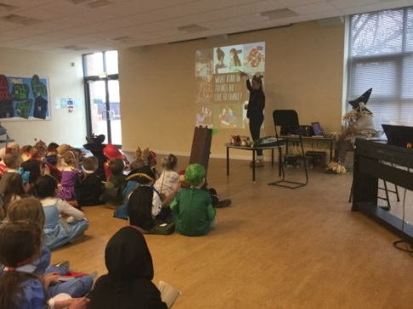All children attend the Prep School Assembly on Monday morning, Hymn Practice on Tuesday, and the Prep School Star Assembly on Friday. Throughout the year each class will host an assembly for parents. Notification of these assemblies will be in the Academic Calendar. Assemblies are formal occasions which foster the development of self- restraint and a collective spirit. (They are basically Christian, but are designed to be respectful of other faiths). Assemblies provide an excellent public setting in which to commend children for special work, extra-curricular activities they may take part in, acts of kindness or helpfulness, and to reward them with stickers/special certificates/stars.

# Reward Systems

We positively reinforce good behaviour and high standards using the School House Point system, Circle Time and good work assemblies at which children’s work and behaviour are publicly rewarded. The School has a Good Behaviour Policy.

# The House System

Points are given for work or behaviour in which extra effort has been shown by the children. The four Houses are:

Holmes Yellow

Sparks Green

Peckover Blue

Clarkson Red

Each pupil is placed in a House on entry to the School. House badges may be purchased from the Magdalene House Preparatory School Office for a nominal cost. The Star Assembly, held once a week, celebrates the occasions when children have gained a star for their House by obtaining 20 points for good work/behaviour. Regular events and inter-House competitions are organized to promote a sense of ‘belonging’ to one’s House, and these are held in individual classes, in sports and through whole School activities.

# Code of Conduct

The School’s Code of Conduct is a positive statement of what is expected of each child while at School. It reads as follows:

1. We are always polite and well mannered
2. We are kind to one another and do not hurt anyone
3. We listen to one another
4. We are truthful
5. We do as we are asked the first time
6. We respect others and try to understand their feelings
7. At all times we are sensible and act safely
8. We seek help when we are unhappy
9. We organise ourselves and our belongings
10. We take pride in the appearance of ourselves, our work and our School.

This Code of Conduct is reinforced both in class and in assemblies with all children. It is understood and followed by all members of our School – Lunchtime Supervisors, Teaching Assistants, Teachers and Office staff.

Within our School, even the youngest children are encouraged to behave towards each other with kindness and consideration. They have to learn to look after their possessions and to respect other’s possessions. We expect them to be honest, helpful and polite, and to work hard and to listen to others. They should respect everyone and learn to value differences and diversity. Mrs Oram, the Reception Class Teacher, is in day to day charge of the management of behaviour in the class, a responsibility that has been delegated to her by Mrs Neaves, Senior Deputy Head, Magdalene House.

We explain to children why some forms of behaviour are unacceptable and hurtful to others. We rarely need to impose sanctions, but sometimes we may remove a treat for hurtful behaviour. Occasionally, a child may be sent to see the Senior Deputy Head, Magdalene House (who is responsible for behaviour management) who will explain the inappropriateness of a particular action. Parents are informed via a note in the Homework Diary when any sanction or reproof is needed, and in cases of repeated instances of hurtful or inappropriate behaviour, they will be invited into the School to discuss the situation with Mrs Oram, the Reception Class Teacher, to agree on a joint way of handling the difficulty.

We follow the Statutory Regulations regarding Managing Pupil behaviour as stated below:

* 1. Providers must not give corporal punishment to a child. Providers must take all reasonable steps to ensure that corporal punishment is not given by any person who cares for or is in regular contact with a child, or by any person living or working in the premises where care is provided. Any Early Years provider who fails to meet these requirements commits an offence. A person will not be taken to have used corporal punishment (and therefore will not have committed an offence), where physical intervention was taken to avert immediate danger of personal injury to any person (including the child) or to manage a child’s behaviour if necessary. Providers, including childminders, must keep a record of any occasion where physical intervention is used, and parents and/or carers must be informed on the same day, or as soon as reasonably practicable thereafter.
  2. Providers must not threaten corporal punishment, and must not use or threaten any punishment which could adversely affect a child’s well-being. (Taken from Statutory Framework for the Early Years Foundation Stage)

Other information concerning the welfare of the children (Anti-Bullying, Child Protection, Health and Safety on Trips, Good Behaviour and Sanctions) is available either on the website or by request from the School.

# Visits

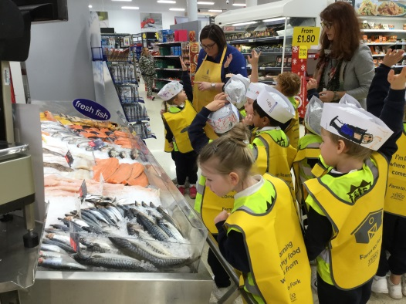We organise many excursions to explore our local area and community, as well as trips further afield to support and enrich our diverse curriculum, enabling the children to acquire a basic understanding of the natural world, our traditions and of the importance of other cultures. The School Calendar lists the major visits that are due to take place over the coming term. We require signed permission slips for visits. We send letters well in advance, telling parents/carers about every visit and, if appropriate, its cost, and whether it involves an extension to the normal length of the School Day.

Copies of our policy on visits for children and Health and Safety on Trips (which includes EYFS children) are available on the School website or can be requested from the School. Please note the ratios of adults to children are generous on EYFS visits, and staff have the appropriate paediatric first aid certificates.

To simplify administration, we have included a ‘Permission to Travel’ form which gives parental consent for pupils to walk, travel by mini-bus, coach or another form of transport while taking part in School activities. Parents/carers will be notified before any events which include travel.

The School reserves the right to withdraw a pupil from any School trip should the attitude or behaviour of the pupil give rise to the belief that he/she may compromise the safety of other individuals on the trip.

# Keeping in Touch

We appreciate that sending a child to start School in Reception is a big step and that it is understandable that some parents/carers may worry or feel anxious about their child’s well-being and happiness; this is why we invite parents and their children to have regular contact with the School before joining us. Once their child has joined us, parents are always welcome to visit the School.

The Reception Class Teacher is responsible for each Reception child’s pastoral care and, with our relatively small classes, quickly gets to know every individual child extremely well. During the initial settling in period (the first month), parents/carers may bring or send their child/ren directly to the classroom on arrival. Parents/carers are welcome to see the Class Teacher twice a day when dropping off and collecting their child and many worries can be readily resolved by an informal chat. Otherwise, parents/carers are welcome to make an appointment for a longer (or more private) conversation with Mrs Oram, the Class Teacher, Mrs Crawley, Leader of Teaching and Learning, or Mrs Neaves, Senior Deputy Head Magdalene House. Any concerns will always be treated in complete confidence.

The Senior Deputy Head produces a Weekly Bulletin for parents, with news about School matters, activities and outings. Children are also encouraged to take home their artwork to display at home. We send invitations to parents/carers to a number of events during the year including:

* Concerts
* The Nativity Play
* The Carol Service
* Magdalene House Preparatory School Production
* Inter-House Athletics
* Various Fairs
* e-Safety
* Speech Day

# Parents’ Evenings

We hold Parents’ evenings during the Michaelmas and Lent terms at which parents/carers have the opportunity to meet with their child’s Teacher and discuss their child’s progress, see their Foundation Stage Profile and to discuss any matters arising.

Please note that on evenings when parents’ evenings take place that only Play and Activities Club will take place for Reception – Prep 2 (and only Homework Club for Prep 3 - Prep 6).

# EYFS Profile Progress and Reports

Children are assessed throughout their time in Reception through observations, questioning and guiding using Tapestry and Early Learning Goals in the Foundation Stage Profile. We currently use an iPad to aid with the recording of observations for each child’s individual profile.

We use the Homework Diary as a way of keeping parents informed about their child’s daily activities, and may use it to suggest activities that reinforce areas of classroom work. Each week’s achievements are briefly noted. Parents are welcome to see how their child is progressing with the Early Learning Goals and to see their child’s profile or view their child’s journal online using a secure login.

In accordance with the Early Years Foundation Stage (EYFS) reporting, parents with children in the Reception Class will be given a detailed written summary of their child’s progress with reference to the Early Learning Goals by the end of the Trinity term. Parents have a copy and are welcome to discuss their child’s EYFS profile result sheet which gives information about their son’s/daughter’s development and learning achievements against the standards expected. Parents are also shown their child’s profile at Parents’ Evenings.

The Early Learning Goals are determined by the Government, and we are required to send the results of the EYFS profiles to the Local Education Authority at Cambridgeshire County Council. Copies are also passed on to the Prep 1 Teacher to enable progress and continuity to be maintained.

Additional assessments are also carried out at the end of the academic year. The results of these are used internally throughout the School to monitor and track the progress of children.

Narrative reports are prepared on each child and sent to parents at the end of the Michaelmas and Trinity terms.

# Communication

## Absence due to Illness

If a child has been ill (vomiting/diarrhoea/infection) parents are asked not to bring them to School until 48hrs have elapsed, or they have been cleared to return to School by a doctor. An ill child will not be happy in School, and will only infect others. We will, therefore, telephone parents/carers and ask them to collect their children if they become ill during the day.

If a pupil is away due to illness parents/carers should telephone the School as soon as possible. A message can be left on the School telephone absence line (found by selecting option 3 when dialling the School switchboard). This line is available during and out of School hours.

Alternatively, the Pupil Services Team can be contacted at the start of the School Day. If a pupil is away from School for more than three consecutive days, parents/carers should telephone School on each day of absence before 08:45 in the morning.

Pupils who have been absent from School through illness must, on their return, bring to the class Teacher an explanatory note from their parents/carers; this also applies if the child was sent home from School because of illness. We are required by the Department of Education to ask for absence notes, and it would be greatly appreciated if parents/carers would co-operate with this.

## Planned Absence

We expect parents to book holidays, medical appointments and any other appointments out of School time. School holiday dates are published a year in advance. Should the need arise for non-attendance during term time, letters requesting such an absence should be addressed to the Senior Deputy Head of Magdalene House. Letters simply stating that a child will be absent are not acceptable, and the child/ren’s absence will be recorded in the register as ‘absent – unauthorised’.

If a child needs to be out of School during the School Day, prior notification of the time and the reason should be given. The child should be collected from the Pupil Services. If the child returns to School later in the day, he/she should be taken to Pupil Services. On both occasions, parents/carers will be asked to sign a register.

# Medical Matters

We will always contact parents/carers if their child suffers anything more than a trivial injury, or if they become unwell during School Day, or if we have any worries or concerns about their child’s health.

We will ask parents to collect their child if they become ill during the School day. The child will be cared for in School until parents/carers can be contacted and their child collected from the School.

As a matter of course parents/carers will be informed of ‘head bumps’. A sticker will be given to the child, and the child will be monitored by staff during the School Day. If it is deemed necessary parents/carers will be asked to collect their child and/or take them for further medical help.

We keep records of all treatment that a child receives during his or her time at the School. We record all accidents and injuries to children and of all medicines that are given to children. We will always inform parents/carers if their child has received medical treatment. For minor injuries, parents are informed with a ‘just to let you know’ sticker which is either given to the child to take home or put into their reading record or Homework Diary.

## First Aid

First aid boxes are located in all classrooms and other prominent places throughout the School. They are checked and, if necessary, replenished on a regular basis. First Aid training for staff is carried out on an annual basis for new staff and to update other members of staff. The following members of Magdalene House Preparatory School staff are qualified Paediatric First Aiders:

Mrs S Davies

Miss S Lemmon

Mrs K Neaves

Mrs E Oram

## Pupils who are Injured or Infectious

If a child sustains an injury that School considers to be of concern, the School will inform parents/carers, giving the option for them to come and check the child and/or take them for further medical help.

## Emergency Medical Treatment

The School will call emergency medical help if it is considered necessary. In accepting a place at the School, parents/carers are required to authorise Mrs Neaves, Senior Deputy Head Magdalene House acting on their behalf (in loco parentis) to consent on the advice of an appropriately qualified medical specialist to their child receiving emergency medical treatment, including general anaesthetic and surgical procedure under the NHS, if parents/carers are unable to be contacted in time.

If the School believes that the child is suffering from a notifiable disease identified as such in the Public Health (Infectious Diseases Regulations 1988) then the child will be isolated until parents/carers can collect their son/daughter. The School will act on any advice given by the Health Protection Agency and inform Ofsted of any action taken.

## Medicines and Treatments Brought to School for Pupils

We ask parents/carers to advise the School of any medication that they bring into the School for their child. If parents have a child with a medical condition that necessitates regular access to medication, parents are requested to inform Mrs Oram, the Teacher of Reception, so that an appropriate regime can be devised. The relevant staff will be informed, in confidence, of any condition that is likely to affect a child in any area of School life. We will work with parents/carers in making arrangements that work best for their child.

## Immunisations

Nurses come into school to administer flu immunisations, therefore, there is no need for parents to arrange these through their GP unless that is your preference. Flu vaccinations for Reception up to and including Prep 5 will take place. Consent forms are sent out a month or so beforehand.

## School Medication Policy

Legally, schools are not bound to administer medication to the children. However, it is School policy to assist children and parents by administering medicines in School time. The School does impose certain conditions before medicine is given to the children in its care:

* Parents/carers must ensure that medicines are clearly marked with the child’s name, the dosage and times the medicine needs to be given.
* Parents/carers must hand the medicine to Pupil Services, together with the completed Medical Consent Form, which is available from Pupil Services or can be found on the School website in the parent portal.
* Pupils may not carry any medication, including cough sweets, without prior written permission from the School and parents/carers.
* Please note that a fridge is available in School for medicines that need to be stored below room temperature.

The same rules will apply to children participating in trips and visits. Again, parents/carers are asked to complete the relevant documentation prior to the trip taking place, and to hand all medication to the trip leader.

Copies of our First Aid Policy (which includes information on Administering Medicines) can be sent to parents/carers upon request. Written consent is required from parents/carers for every medicine before we administer it to their child.

# Maintaining a Safe and Secure Environment

The safety of the children is our highest priority, and because they are so young, we need to be particularly vigilant. We will, therefore:

* Only allow a child to go home with their parent, unless we have received advance parental permission (in writing) that he or she may be collected by another adult.
* Never allow a child to leave the premises unsupervised. There is always at least one adult in charge of the outside play area – which is fenced and secure.
* Ask all visitors to identify themselves and to state their business before we give them access to the premises. Visitors sign in, wear security badges and are escorted throughout their visit. They sign out on leaving.
* Register all pupils at the start of the morning and afternoon sessions.
* Check all pupils out as they are collected by their parents/carers.

The entrance to our building leads to our School Office, which is equipped with a seating area for visitors. This entrance has security locked doors which can only be opened from the inside by authorised adults. All visitors will be asked to wait in the Visitors’ Reception Area until they have signed in and their escort has arrived.

Parents/Carers collecting their child/ren at 15:30 at the end of the School Day are asked to wait at one of the Coloured Gates where their child will be handed over by the Teacher or a Teaching Assistant. If it is raining, children are released either through the door in the archway near the Main School Entrance or from the Alan Salmon Hall near the ‘Pirate Ship’ gate.

## On-Site Health and Safety

We update and review our risk assessments on the Reception classroom and other indoor areas, the outdoor play space and all the equipment and toys used by the children every year to ensure that everything with which the children may come into contact has been assessed and that any potential hazards are kept to a minimum. Sample risk assessments for EYFS are available on the School website. We welcome comments and suggestions from parents for improvement.

# Admissions

Magdalene House Preparatory School is a school that caters for children from 3-11 years of age. Children are admitted to Magdalene House Preparatory School at any stage during the academic year subject to a satisfactory assessment.

Young children approaching school age may join the Reception class at the beginning of the school year in which they turn five. All children who come to the School will be invited to spend a Taster Day with us. They then return at a later date to be assessed in a manner appropriate to their age. Places will be offered on the basis of this assessment.

Magdalene House Preparatory School is registered with the DFE as an Early Years’ Provider. We accept ‘Computershare’ childcare vouchers.

As an integral part of the School, the Reception children make full use of the School facilities, such as the Alan Salmon Hall, Skelton Hall and Sports Hall although they have a separate classroom and outdoor play area. We expect the children in Reception to remain pupils in Magdalene House Preparatory School until they reach the age of 11. A place in the Senior School is by selection, but all pupils from our Preparatory School will automatically be considered for selection to the Senior School.

We expect children to be toilet trained, to dress and undress with minimum help and to be able to use a knife and fork before they join us.

The whole School’s Admissions Policy applies to Reception class as much as to the rest of the School and copies can be sent to parents/carers on request.

## Children with Medical or Special Educational Needs who require special adjustments

As stated in the Admissions Policy places are offered on the basis of an assessment appropriate to the child’s age. If a child has medical needs, special education needs or requires any special adjustments, we will invite the parents to a meeting with the Senior Deputy Head Magdalene House, the Head of Learning Support – Prep School (Mrs Claire Harding) and the Reception Class Teacher. The Leader of Teaching and Learning may be involved and in addition any outside Specialist who has been involved with the care of the child. If appropriate, the school nurse will write an individual healthcare plan in partnership with parents; this is to enable thorough discussion on the regime that is most appropriate for the child’s individual care, well before the child joins the Reception Class.

## English as an Additional Language

We are aware that pupils with EAL in the Reception class may well have no particular learning difficulty in the sense that they have special educational needs and that they are in a position similar to that of any pupils learning a language other than their mother tongue. As a school, we take reasonable steps to provide opportunities for children to develop and use their home language in play and learning, supporting their language development at home.

We provide for all pupils:

* a wide range of opportunities for speaking and listening;
* effective models of spoken and written language;
* a welcoming environment in which children feel confident and can contribute.

Support may be available for pupils whose first language is not English and who might benefit from extra tuition, for which there is an extra charge. Parents can be advised of external agencies that could provide such an assessment, and we have the name of a private tutor who can help. Parents/carers are asked to contact the School for further information if they so wish.

## Equal Opportunities Policy

We welcome children from a diverse range of backgrounds and pride ourselves on being an inclusive community where there is complete equality of opportunity, and everyone is valued for being him or herself. A copy of the School’s Equal Opportunities Policy (which includes EYFS) is available on the School website and can be sent to parents/carers on request.

# Safeguarding/Child Protection

The School’s Safeguarding and Child Protection Policies, including policies for Intimate Care and the Safer Recruitment of Staff, are enforced rigorously in the Reception Class, as well as throughout the School. We comply with all the relevant Early Years Statutory Safeguarding and Welfare Requirements, and copies of the pertinent policies, including those which apply throughout the School, can be found on the School website or by request from the School.

All staff receive training in Child Protection and Child Protection Procedures as statutorily required. We also comply with the Childcare Act 2006 and the Childcare (Disqualification) regulation 2009 with regard to staff employed in an EYFS setting.

## E-Safety

In addition to the filtering and monitoring facilities which are part of the School’s IT network, we run regular e-safety awareness programmes for pupils, parents and staff. All parents and staff are asked to sign a copy of the e-safety Policy to acknowledge that they have read and agree with the School’s approach in this matter. Copies of the relevant policies are available on the School website.

## Use of Camera and Recording Equipment in EYFS

Magdalene House Preparatory School aims to achieve a balance between safeguarding the children and young people in our care and ensuring families can experience pleasure and pride in their children’s achievements through the use of technology. To this end, we use a tablet computer and a recording programme called Tapestry (further details on the Security and Privacy of the software is available on the Tapestry website or on request from the School). In accordance with the Data Protection Act 1998:

* Only the camera and recording equipment belonging to the setting will be used to take appropriate and relevant images of children, i.e. observations, photographs of setting events.
* Images will be used in accordance with the Data Protection Act 1998.
* Cameras and recording equipment will only be used where two or more staff members are present.
* The setting’s electronic devices will only be used for work-related matters.
* If there were any circumstances where there might be a suspicion that the material on the setting’s mobile device might be unsuitable and provide evidence relating to a criminal offence, the ‘Allegations of Abuse’ process will be followed (please refer to Wisbech Grammar School ‘Safeguarding and Child Protection Policy’).
* The setting’s tablet computer remains the property of the setting at all times and will not be taken off of the premises (with the exception of visits and outings).

# Concerns and Complaints

We hope that parents/carers will not feel the need to complain and that any difficulty can be sensitively and efficiently handled before it is felt necessary to consult the School’s ‘Complaints Policy’. Staff are usually available to meet with parents/carers at short notice, and we take your concerns extremely seriously. The School’s ethos is to deal with any problems, however small, immediately, to ensure that all children are happy and secure. Further information regarding the School’s formal complaints procedure and the number of formal complaints registered is available on request from the Bursar. We undertake to investigate all written complaints relating to the fulfilment of the EYFS requirements and notify complainants of the outcome of the investigation within 28 days of having received the complaint. The Record of Complaints will be made available to Ofsted on request. Records of complaints and their outcome are maintained within School.



Complaints may also be taken to ISI (Independent Schools Inspectorate) or Ofsted. The contacts for these bodies are as follows:

**ISI:**

**Ofsted:**

020 7600 0100

020 7710 9900

0300 123 1231

[info@isi.net](mailto:info@isi.net) [concer](mailto:concerns@isi.net)[ns@isi.net](mailto:ns@isi.net)

ofsted.gov.uk

# Storage of Records

We store all of our records on pupils in locked cabinets. Parents/carers may arrange to see the records of their children in accordance with the whole School’s policy on Reports and Record Keeping (which can be sent to parents/carers on request). Parents/carers have the right to make written comments on their child’s records, which will then be treated as part of that record. The School is registered under the Data Protection Act and complies with its provisions for example, about the disclosure of information relating third parties.

# Parking

Parents can park in the Chapel Road carpark.

# Uniform

We want the children to take pride in their appearance and to be good ambassadors for the School at all times. Children should be encouraged to keep their shoes well-polished and uniform clean and tidy.

Boys’ hair should be kept short but not shaved, and girls’ hair should be tied back if long. Uniform lists will be provided as appropriate to age and year band.

Jewellery may not be worn except for one pair of plain ear studs.

The uniform is available online at **schoolblazer.com.** An insert with information can be found with this Handbook.

# Stationery Requirements

## (Reception pupils)

* Art Shirt – please order from School Blazer

## (Prep 1 and 2 pupils)

* Pencils
* Pritt Stick (type with white glue please)
* Sharpener
* Eraser
* Tissues
* Art Shirt – please order from School Blazer

Please ensure that your child has sufficient items of stationery for each term.

# In Conclusion

We hope that your children will be very happy at Magdalene House Preparatory School. My staff and I look forward to meeting you at the many events organised over the course of the year.

With Best Wishes



Mrs Neaves and Team

# Contact Us

#### Please address any correspondence (other than that pertaining to Accounts) to:

Magdalene House Preparatory School Wisbech Grammar School

Chapel Road, Wisbech, PE13 1RH

01945 586 780/01945 583 631



## Accounts Queries

#### For any queries of a financial nature, please direct these in the first instance to the Accounts Office

01945 586 780 (select option 4)



## Admissions Enquiries

#### For any Admissions queries please contact our Admissions Team

01945 586 750



[admissions@wisbechgrammar.com](mailto:admissions@wisbechgrammar.com)