

Kindergarten Class

Information for Parents/Carers

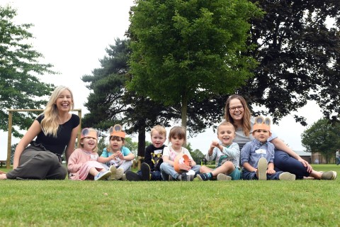

September 2018

# Welcome

#### The staff would like to extend a warm welcome to all the pupils and parents who come to Magdalene House Preparatory School, which is part of the long-established Wisbech Grammar School.

#### This Handbook provides information to help you and your family find out more about the School. However, communication is vital to the Home-School partnership from the outset, so please do contact the School at [pupilservices@wisbechgrammar.com](mailto:pupilservices@wisbechgrammar.com%20) if you have any questions, concerns or queries. There is also more information available on the School website.

**Mrs Keryn Neaves B.Ed Teacher’s Dip, Senior Deputy Head Magdalene House**

## The School

At Magdalene House Preparatory School we intend to provide your children with a wide range of educational opportunities within a family atmosphere inspired by our Christian foundation. We believe that every individual has a contribution to make and this helps to create the special environment of our School, where each child is known and valued.

## Aims of the School

* To ensure that the children feel happy, confident and safe in the School environment.
* To help in the development of well-balanced, independent children.
* To foster tolerance and respect for the differences in each other.
* To improve listening skills and encourage the children to develop greater self-discipline.
* To celebrate the uniqueness and dignity of each individual.
* To provide the foundations for all future learning through a range of activities.

Children’s development and enjoyment of learning in the Early Years is encouraged and stimulated through a variety of different activities in a secure indoor and outdoor environment, through play, structured learning opportunities and creative activities. The relationships which children develop with each other and with our staff at this stage are central to their happiness and lay the best possible foundation for their future.

All parents of children in the Reception class are invited to a presentation, during the preceding Trinity term, about the EYFS curriculum, and daily routines in the Reception class will be explained.

Table of Contents

Welcome 2

The School 2

Aims of the School 2

Policies 4

Magdalene House Staff 2018-2019 5

Senior Staff 5

Teaching Staff 5

Wisbech Grammar School Specialist Teaching Staff 6

Kindergarten Staff 6

Teaching Assistants 6

Learning Support Assistants 8

Administration Staff 8

Lunchtime Supervisors 8

Contacting School 8

Pupil Services 8

Chair of Governors 8

The Kindergarten Day 9

Bringing and Collecting Your Child 10

Arrival at Kindergarten 10

Initial Settling In 10

Collecting Your Child 10

Procedures When a Child is Not Collected on Time 10

Procedures in the Event of a Child going Missing 10

Foundation Stage Curriculum 11

Prime Areas: 11

Specific Areas: 11

Teaching and Learning 11

Outdoor Learning 12

Food and Drink 13

School Lunches / Snacks / Drinks 13

Special Diets 13

Code of Conduct 14

Visits 15

Keeping in Touch 15

EYFS Profile Progress and Reports 16

Communication 16

Absence due to Illness 16

Medical Matters 17

First Aid 17

Pupils who are Injured or Infectious 17

Emergency Medical Treatment 18

Maintaining a Safe and Secure Environment 18

On-Site Health and Safety 18

Admissions 19

Children with Medical or Special Educational Needs who require special adjustments 19

English as an Additional Language 19

Equal Opportunities Policy 20

Safeguarding/Child Protection 20

E-Safety 20

Use of Camera and Recording Equipment in EYFS 21

Concerns and Complaints 21

Storage of Records 22

Parking 22

Uniform 23

Kindergarten Uniform 23

Kindergarten Girls’ Recommended Uniform 23

Kindergarten Boys’ Recommended Uniform 23

In Conclusion 24

Contact Us 24

Accounts Queries 24

Admissions Enquiries 24

The contents of this Handbook are as accurate as they can be at the time of writing but may be subject to change as the needs of the School vary.

Parents are advised to check with the School the accuracy of any detail which is of particular importance to them or to their child.

# Policies

Available on the Wisbech Grammar School Website that relate to Magdalene House and EYFS specifically:

Admissions Policy (A1)

SEND Policy (A2)

Curriculum Policy (A3)

Anti-Bullying Policy (A4)

Good Behaviour Policy (A4)

PSHCE Policy (A5)

Safeguarding Policy (A6)

First Aid Policy (A7)

Online Safety Policy (A8)

Health and Safety Policy (A9)

Risk Assessment Policy (A10)

Fire Safety Policy (A11)

Supervision Policy (A12)

Complaints Policy (A14)

SEND 3-Year Accessibility Policy (A15)

Whole School and Magdalene House Preparatory School policies are available on the Wisbech Grammar School website: **wisbechgrammar.com**

Or on request from School directly at:  [**pupilservices@wisbechgrammar.com**](mailto:office@wisbechgrammar.com)

# Magdalene House Staff 2018-2019

## Senior Staff

Mrs K Neaves B.Ed Teacher’s Dip Senior Deputy Head Magdalene House

Mrs K Fairbrother B.Ed (Hons) Assistant Deputy Head, Prep 4 Teacher

Mrs T Crawley B.Ed (Hons), MEd Leader of Teaching and Learning, Prep 3 Teacher

## Teaching Staff

Mrs A Beck BA, PGCE Prep 6 Teacher

Miss E Brown City and Guilds Level 3,

Dip in EYFS Practitioner EYFS Practitioner and Learning Support

Mrs K Cook, BA MA PGCE Prep 2 Teacher

Mrs E J Fenn BA (Hons) Support Teacher

Miss M Gillings NCFE L3 Teaching Assistant EYFS Practitioner

Mrs C Harding PG Dip, AMBD Learning Support and Piano/Saxophone/Oboe Teacher GRSM, ARCM

Mr D M Hyland BA (Hons) MA Prep 5 Teacher (2 days)

Mrs A Kelly BA (Hons) Prep 6 Teacher

Mrs G McMullen BA (Hons) Support Teacher

Mrs E Oram BA, PGCE (Hons) EYFS Lead

Mrs J Page B Ed (Hons) Prep 5 Teacher

Mrs C Sandall BA (Hons) Prep 5 Teacher (3 days)

Miss A Thorpe CACHE L4 NVQ, CACHE L3 EYFS Practitioner

Mrs J Whiteman CertEd Prep 1 Teacher

## Wisbech Grammar School Specialist Teaching Staff

Mr M Arnold Prep 5 and 6 Computing

Mrs S Duncan BSc Performing Arts

Mrs S Fox BA, MSc Prep 5 and 6 Science

Mrs S M Goodier BSc PE and Sport

Mr T Jestin MA French

Mr A C Laybourne MSc PE and Sport

Mrs J Missin BA Music

Mr I Rodriguez BA Spanish

Mrs M Skinner German

Mrs A Sloan BSc MA Prep 5 & 6 Food & Nutrition

Mr N Taylor PE and Sport

Mrs M Tooke BSc Prep 3 & 4 Food & Nutrition

Mr P J Webb BA Director of Sport

Mr F Whatling PE and Sport

Mr J D Williams PE and Sport

## Kindergarten Staff

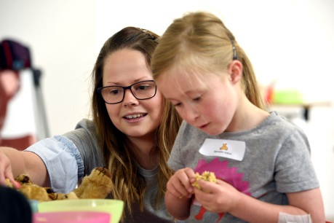 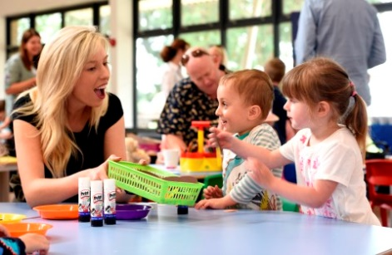 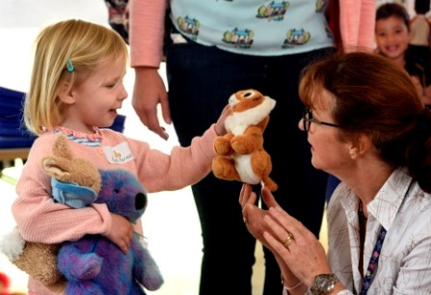

Miss Amy Thorpe and Miss Megan Gillings will oversee the day to day running of the Kindergarten with Mrs Emma Oram, EYFS Lead, ………….

Miss Emma Brown will give support within the Kindergarten at various time throughout the day.

## Teaching Assistants

Mrs V Andrews (NCFE Teaching Assistant Level 2, CACHE Level 3, BTEC National Diploma in Childhood Studies)

Mrs L Barnes (NCFE Teaching Assistant Level 2)

Mrs S Boughen (City and Guilds in Community Care)

Mrs L Field

Ms H French (NVQ Level 3)

Mrs L Gray (BTEC in Nursery Nursing)

Mrs S Peck (NCFE Teaching Assistant Level 2, NVQ Level 3)

Mrs S Porter

Mrs S J Webb (NVQ Level 3, BTEC National Diploma in Sport)

## Learning Support Assistants

Mrs C Ayling

Level 3 Diploma in Specialist Support for Teaching and Learning in Schools QCF. ELKLAN Speech and Language Trainers, Level 2 Teaching and Learning Success at Arithmetic, Spelling and Phonics

Mr F Whatling

Level 2 BTEC First Diploma in Public Services, currently undertaking NVQ Level 3 in Children’s Learning and Development

Mrs M Peukert

## Administration Staff

Mrs S A Davies PA to Senior Deputy Head / Pupil Services

## Lunchtime Supervisors

Mrs P Aldrich

Mrs L Field

Mrs C Hunt

Mrs Michelle Peukert

# Contacting School

Teaching staff and the Senior Deputy Head at Magdalene House are normally available before the start and at the end of the School day dependent on duty, meeting and club commitments.

A Receptionist is in School during term time from 07:45 until 17:30. If you need to contact the School during holiday periods, a Receptionist is usually available from 09.00 until 16:00.

## Pupil Services

Phone: 01945 586780 or 01945 583631

Email: [pupilservices@wisbechgrammar.com](mailto:office@magdalenehouseprep.com)

## Chair of Governors

The Chair of the Governors is Dr D Barter, MB, BS, FRCP, FRCPCH, DCH.

He can be contacted via Wisbech Grammar School, Chapel Road, Wisbech, Cambridgeshire, PE13 1RH.

# The Kindergarten Day

08.30 Start of Kindergarten Day

08.30 Free flow learning environment and self-registration

09.00 Carpet Time – Welcome / Discuss the morning’s activities

09.15 Phonics and Creative Communication (through active games and songs)

Free flow learning environment

10.00 Rolling snack time / indoor free flow learning environment

Enhancement of story /rhyme / song

10.30 Focus small group maths activity – free flow learning environment

11.05 Getting ready for lunch

11.15 Lunch time – Skelton Hall

12.30 Morning session ends

12.30 Home time/Self-registration

Free flow learning environment

13.00 Free flow learning environment with Creative/Topic focus

14.00 Snack time. Story / song / rhyme

14.30 Free flow learning environment with KUW/Topic focus

15.40 Tidy up time

15.50 Story / goodbye

16.10 Home / End of Kindergarten Day

A Breakfast Club is also available in the Skelton Hall from 07.45 – 08.20 (see website for details) Pupils must be brought to the Main Reception area to sign in

*This timetable is to give you a general guide about what your child will be doing during their time at Kindergarten. We follow the EYFS curriculum and with this in mind we will tailor our provision to suit the individual needs and development stage of the children in our sessions. In addition to our regular activities on some days we will have Languages, Music and Swimming sessions delivered by expert teachers. We will let you know about the opportunities for swimming in advance.*

# Bringing and Collecting Your Child

## Arrival at Kindergarten

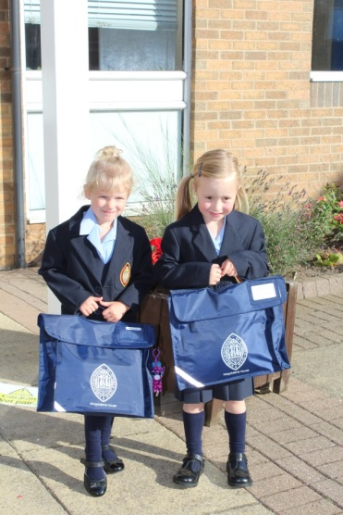Pupils may arrive from 0745 onwards. Please ensure you advise us in advance if you require a different drop off time to your initial selected time.

In the mornings, please park in the main School carpark off Chapel Road and take your child/ren to Pupil Services/ Main School Reception. Access to the Kindergarten is through Pupil Services.

## Initial Settling In

We have a variety of settling in sessions including home visits and sessions within the setting which we run throughout the year for you and your child to get to know the staff and the setting.

We hope that by the time your child is ready to start Kindergarten that they will feel comfortable and happy; however, we understand that all children are different and we can offer a shorter day or a series of short sessions to help your child settle in. Please talk to Mrs Neaves, Miss Gillings or Miss Thorpe about this.

## Collecting Your Child

Children may be collected from the entrance to the Kindergarten through Pupil Services at your selected pick up time. If you wish to collect your child at an alternative time to the one you have advised us of, please notify Pupil Services at the earliest convenience.

## Procedures When a Child is Not Collected on Time

If for any reason the person collecting the children is delayed, they should inform the School via Pupil Services as soon as possible. Any pupils who cannot be collected as a result of the delay will be supervised by a member of staff for as long as necessary.

## Procedures in the Event of a Child going Missing

In the unlikely event that a child is lost, or goes missing, the parents/carers and relevant authorities will be informed. The grounds and buildings would be searched and checks made. The ‘Missing Child’ policy explains procedures if such an event were to occur.

# Foundation Stage Curriculum

Within our Kindergarten and Reception classes we offer a broad and balanced Foundation Stage curriculum for our youngest pupils based upon the (Sept. 2012 Revised) Development Matters EYFS Curriculum. All children are given equal access and opportunities to develop their knowledge and skills in the areas listed below:

## Prime Areas:

* Personal, Social and Emotional Development
* Communication and Language
* Physical Development

## Specific Areas:

* 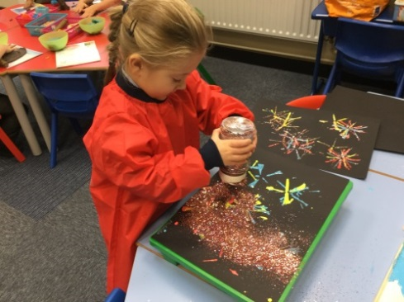Literacy
* Mathematics
* Understanding of the World
* Expressive Arts and Design

## Teaching and Learning

In the Early Years there are three aspects to The Learning Environment: The Indoor, The Outdoor and The Emotional. In our Kindergarten we consider all these aspects as equally important and we have developed our learning spaces to encourage independent learning in all areas of the EYFS curriculum. Our staff are experienced and well qualified to support the children through adult led sessions and by scaffolding children’s learning when working alongside them.

We have been influenced by Reggio Emilia and Montessori philosophies to develop our own ethos and to create a warm and stimulating child-led setting.

We believe in a holistic approach to learning where all areas of the environment can support each other and every prime and specific area of the curriculum enhancing children’s learning through play and independent choices.

## Outdoor Learning

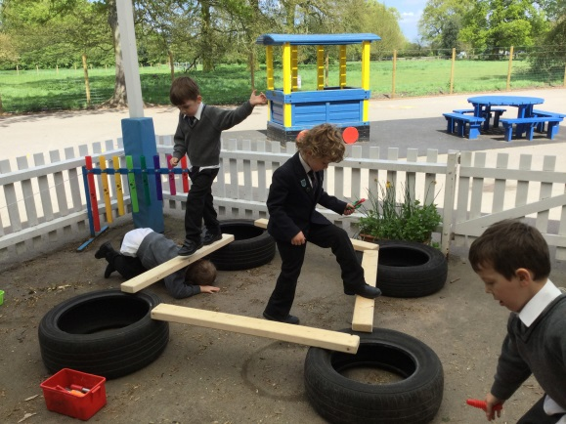All of the Kindergarten children are encouraged to play in a secure outdoor space throughout the day. We have a dedicated covered canopy area that is accessed from the classroom; this has been developed to cater for a wide variety of outdoor activities linked to the EYFS curriculum. We use the open ‘triangle’ playground area for supervised activities, including playing with the large outdoor play equipment such as the tricycles and scooters as well as various ball games.

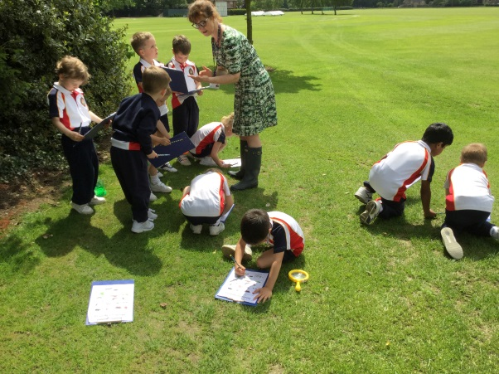In addition the children are regularly taken in supervised groups around the School grounds to learn about the seasons of the year, by collecting autumn leaves and observing mini-beasts etc. They are also encouraged to plant and grow their own seeds in the Spring. Outdoor learning is a key requirement for the EYFS curriculum; therefore children will need a pair of named Wellington boots (navy preferably) that can be left at School at all times. Children will be provided with an all in one weatherproof suit but will also need to bring a coat with them every day so that they may participate in Outdoor Learning activities, whatever the weather.

Parents/carers can access more information from the Department of Education (DofE) website at the links below to learn more about how the EYFS is being delivered in our setting:

[https://www](http://www.gov.uk/government/publications/2010-to-2015-government-policy-).gov[.uk/government/publications/2010-to-2015-government-policy-](http://www.gov.uk/government/publications/2010-to-2015-government-policy-) childcare-and-early-education/2010-to-2015-government-policy-childcare-and- early-education#appendix-2-early-years-foundation-stage

[https://www](http://www.gov.uk/government/publications/early-years-foundation-stage-).gov[.uk/government/publications/early-years-foundation-stage-](http://www.gov.uk/government/publications/early-years-foundation-stage-) framework--2

We utilise another useful document within the Early Years called ‘Development Matters’, a pdf version of this document can be found at:

<http://www.foundationyears.org.uk/files/2012/03/Development-Matters-FINAL-> PRINT-AMENDED.pdf

# Food and Drink

## School Lunches / Snacks / Drinks

Children will be provided with a balanced, cooked meal for their lunch. Lunch will be eaten in the Skelton Hall. Please ensure the school are aware of any allergies or dietary requirements.

Children will be provided with a healthy snack for both morning and afternoon break. Drinking water is available throughout the day, as we fully recognise the importance of adequate hydration.

At lunchtime, the children are escorted to the Skelton Hall by the Kindergarten teachers. The children are taken earlier than the rest of the School so they can be served and seated first.

Weekly menus will be provided.

## Special Diets

Parents of children who have allergies to any food product, or who have special dietary requirements, are asked to make this clear on the Medical Questionnaire sent in the information prior to their child starting in the Kindergarten. Parents should inform the Kindergarten teachers at once if their son or daughter subsequently develops intolerance to any food. The School Catering Manager is happy to be contacted by any parent who has concerns about their son or daughter’s medical condition or dietary requirements and to devise a special menu, where practically possible.

# Code of Conduct

The School’s Code of Conduct is a positive statement of what is expected of each child while at School. It reads as follows:

1. We are always polite and well mannered
2. We are kind to one another and do not hurt anyone
3. We listen to one another
4. We are truthful
5. We do as we are asked the first time
6. We respect others and try to understand their feelings
7. At all times we are sensible and act safely
8. We seek help when we are unhappy
9. We organise ourselves and our belongings
10. We take pride in the appearance of ourselves, our work and our School.

This Code of Conduct is understood, followed and reinforced by all members of by all members of our School.

Within our School, even the youngest children are encouraged to behave towards each other with kindness and consideration. They have to learn to look after their possessions and to respect other’s possessions. We expect them to be honest, helpful and polite, and to work hard and to listen to others. They should respect everyone and learn to value differences and diversity. Miss Thorpe and Miss Gillings, the Kindergarten Class Teachers, are in day to day charge of the management of behaviour in the class.

We explain to children why some forms of behaviour are unacceptable and hurtful to others. We rarely need to impose sanctions, but sometimes we may remove a treat for hurtful behaviour. Occasionally, a child may be sent to see the EYFS Lead. Parents would be informed if inappropriate behaviour continues after regular classroom management intervention has been unsuccessful.

We follow the Statutory Regulations regarding Managing Pupil behaviour as stated below:

* 1. Providers must not give corporal punishment to a child. Providers must take all reasonable steps to ensure that corporal punishment is not given by any person who cares for or is in regular contact with a child, or by any person living or working in the premises where care is provided. Any Early Years provider who fails to meet these requirements commits an offence. A person will not be taken to have used corporal punishment (and therefore will not have committed an offence), where physical intervention was taken to avert immediate danger of personal injury to any person (including the child) or to manage a child’s behaviour if necessary. Providers, including childminders, must keep a record of any occasion where physical intervention is used, and parents and/or carers must be informed on the same day, or as soon as reasonably practicable thereafter.
  2. Providers must not threaten corporal punishment, and must not use or threaten any punishment which could adversely affect a child’s well-being. (Taken from Statutory Framework for the Early Years Foundation Stage)

Other information concerning the welfare of the children (Anti-Bullying, Child Protection, Health and Safety on Trips, Good Behaviour and Sanctions) is available either on the website or by request from the School.

# Visits

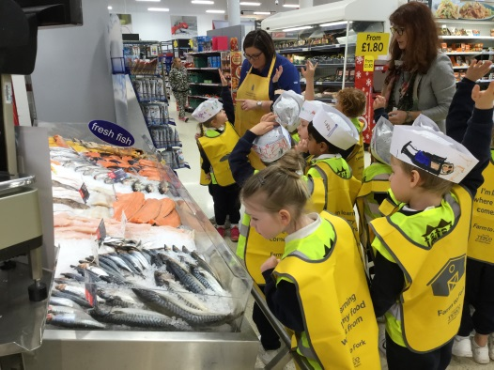We aim to organise many excursions to explore our local area and community, as well as trips further afield to support and enrich our diverse curriculum, enabling the children to acquire a basic understanding of the natural world, our traditions and of the importance of other cultures. The School Calendar lists the major visits that are due to take place over the coming term. We require signed permission slips for visits. We send letters well in advance, telling parents/carers about every visit.

Copies of our policy on visits for children and Health and Safety on Trips (which includes EYFS children) are available on the School website or can be requested from the School. Please note the ratios of adults to children are generous on EYFS visits, and staff have the appropriate paediatric first aid certificates.

To simplify administration, we have included a ‘Permission to Travel’ form which gives parental consent for pupils to walk, travel by mini-bus, coach or another form of transport while taking part in School activities. Parents/carers will be notified before any events which include travel.

The School reserves the right to withdraw a pupil from any School trip should the attitude or behaviour of the pupil give rise to the belief that he/she may compromise the safety of other individuals on the trip.

# Keeping in Touch

In our Kindergarten we use “Tapestry” – an online assessment and reporting tool which we can use to record children’s development against the EYFS Profile. We are also able to use this to share photographs, comments and videos about your child’s time at Kindergarten with you. We will try to do this at least weekly, hopefully more. You are also able to comment on photographs or add anything your child has been busy doing or learning outside of Kindergarten,

We have a statutory responsibility to report to parents on the Characteristics of Effective Learning and we will do this using regular Tapestry updates and at the end of the School year narrative reports in paper form will be sent to parents at the end of the Trinity Term.

If you would like to talk to a member of Kindergarten staff about your child you are welcome to have a catch up at the beginning or end of the day; however, this is a busy time and if you would like to discuss something more in depth you are invited to make an appointment for this. Please speak to Miss Gillings and/or Miss Thorpe.

# EYFS Profile Progress and Reports

Children are assessed throughout their time in Kindergarten through observations, questioning and guiding using Tapestry and Early Learning Goals in the Foundation Stage Profile. We use an iPad to aid with the recording of observations for each child’s individual profile.

We use a home school diary as a way of keeping parents informed about their child’s daily activities as well as informally catching up with parents/carers at the end of each session.

Parents are welcome to see how their child is progressing with the Early Learning Goals and to see their child’s profile or view their child’s journal online using a secure login.

In accordance with the Early Years Foundation Stage (EYFS) reporting, parents with children in the Kindergarten Class will be given a detailed written summary of their child’s progress with reference to the Early Learning Goals by the end of the Trinity term. Parents have a copy and are welcome to discuss their child’s EYFS profile result sheet which gives information about their son’s/daughter’s development and learning achievements against the standards expected. Parents are also shown their child’s profile at Parents’ Evenings.

# Communication

## Absence due to Illness

If a child has been ill (vomiting/diarrhoea/infection) parents are asked not to bring them to Kindergarten until 48hrs have elapsed, or they have been cleared to return to Kindergarten by a doctor. An ill child will not be happy in Kindergarten, and will only infect others. We will, therefore, telephone parents/carers and ask them to collect their children if they become ill during the day. Please ensure the course of medicine has been completed before they return to the setting.

If a pupil is away due to illness parents/carers should telephone the Kindergarten as soon as possible. A message can be left on the main School telephone absence line (found by selecting option 3 when dialling the School switchboard). This line is available during and out of School hours.

Alternatively, the Pupil Services Team can be contacted at the start of the Kindergarten Day. If a pupil is away from Kindergarten for more than three consecutive days, parents/carers should telephone Kindergarten on each day of absence before 0830.

## 

# Medical Matters

We will always contact parents/carers if their child suffers anything more than a trivial injury, or if they become unwell during the Kindergarten Day, or if we have any worries or concerns about their child’s health.

We will ask parents to collect their child if they become ill during the Kindergarten day. The child will be cared for in Kindergarten until parents/carers can be contacted and their child collected from the Kindergarten.

As a matter of course parents/carers will be informed of ‘head bumps’. A sticker will be given to the child, and the child will be monitored by staff during the Kindergarten Day. If it is deemed necessary parents/carers will be asked to collect their child and/or take them for further medical help.

We keep records of all treatment that a child receives during his or her time at the Kindergarten. We record all accidents and injuries to children and of all medicines that are given to children. We will always inform parents/carers if their child has received medical treatment. For minor injuries, parents are informed with a ‘just to let you know’ sticker which is given to the child to take home.

## First Aid

First aid boxes are located in all classrooms and other prominent places throughout the School and Kindergarten. They are checked and, if necessary, replenished on a regular basis. First Aid training for staff is carried out on an annual basis for new staff and to update other members of staff. The following members of Magdalene House Preparatory School staff are qualified Paediatric First Aiders:

Mrs S Davies

Miss M Gillings

Miss S Lemmon

Mrs K Neaves

Mrs E Oram

Miss A Thorpe

## Pupils who are Injured or Infectious

If a child sustains an injury that School considers to be of concern, the School will inform parents/carers, giving the option for them to come and check the child and/or take them for further medical help.

## Emergency Medical Treatment

The School will call emergency medical help if it is considered necessary. In accepting a place at the Kindergarten, parents/carers are required to authorise Mrs Neaves, Senior Deputy Head Magdalene House acting on their behalf (in loco parentis) to consent on the advice of an appropriately qualified medical specialist to their child receiving emergency medical treatment, including general anaesthetic and surgical procedure under the NHS, if parents/carers are unable to be contacted in time.

If the School believes that the child is suffering from a notifiable disease identified as such in the Public Health (Infectious Diseases Regulations 1988) then the child will be isolated until parents/carers can collect their son/daughter. The School will act on any advice given by the Health Protection Agency and inform Ofsted of any action taken.

# Maintaining a Safe and Secure Environment

The safety of the children is our highest priority, and because they are so young, we need to be particularly vigilant. We will, therefore:

* Only allow a child to go home with their parent, unless we have received advance parental permission (in writing) that he or she may be collected by another adult.
* Never allow a child to leave the premises unsupervised. There is always at least one adult in charge of the outside play area – which is fenced and secure.
* Ask all visitors to identify themselves and to state their business before we give them access to the premises. Visitors sign in, wear security badges and are escorted throughout their visit. They sign out upon leaving.
* Register all pupils at the start of the morning and afternoon sessions.
* Check all pupils out as they are collected by their parents/carers.

The entrance to our building leads to our School Office (Pupil Services), which is equipped with a seating area for visitors. This entrance has security locked doors which can only be opened from the inside by authorised adults. All visitors will be asked to wait in the Visitors’ Reception Area until they have signed in and their escort has arrived.

Parents/Carers collecting their Kindergarten child/ren are asked to wait at Pupil Services where their child will be handed over by the Kindergarten Teacher.

## On-Site Health and Safety

We update and review our risk assessments on the Kindergarten classroom and other indoor areas, the outdoor play space and all the equipment and toys used by the children every year to ensure that everything with which the children may come into contact has been assessed and that any potential hazards are kept to a minimum. Sample risk assessments for EYFS are available on the School website. We welcome comments and suggestions from parents for improvement.

# Admissions

Magdalene House Preparatory School is a school that caters for children from 3-11 years of age. Children are admitted to Magdalene House Preparatory School at any stage during the academic year subject to a satisfactory assessment.

The standard timing for accepting children into the Kindergarten is from the start of the term following their third birthday. This is approximately the same timing that triggers eligibility to Early Years Funding (with slight complications for example for children born in April who must wait until the following September).

However, as children develop at different stages and ages we will meet each child to assess their ability to manage in the setting and participate in activities. An individual plan for each child will be agreed with the parents, and this may enable them to start a little early, for example at the start of the term they turn three or defer their start for a further term.

The transition through to the Reception Class will commence in the Lent term when settling in sessions and family events will be held to familiarise you with the next step.

Magdalene House Preparatory School is registered with the DFE as an Early Years’ Provider. We accept ‘Computershare’ childcare vouchers.

As an integral part of the School, the Kindergarten children make full use of the School facilities, such as the Alan Salmon Hall, Skelton Hall and Sports Hall although they have a separate classroom and outdoor play area. We expect the children in Kindergarten to remain pupils in Magdalene House Preparatory School until they reach the age of 11. A place in the Senior School is by selection, but all pupils from our Preparatory School will automatically be considered for selection to the Senior School.

The whole School’s Admissions Policy applies to Kindergarten class as much as to the rest of the School and copies can be sent to parents/carers on request.

## Children with Medical or Special Educational Needs who require special adjustments

As stated in the Admissions Policy places are offered on the basis of an assessment appropriate to the child’s age. If a child has medical needs, special education needs or requires any special adjustments, we will invite the parents to a meeting with the Senior Deputy Head Magdalene House, the Head of Learning Support – Prep School (Mrs Claire Harding) and the Kindergarten Team. The Leader of Teaching and Learning may be involved and in addition any outside Specialist who has been involved with the care of the child. If appropriate, the school nurse will write an individual healthcare plan in partnership with parents; this is to enable thorough discussion on the regime that is most appropriate for the child’s individual care, well before the child joins the Reception Class.

## English as an Additional Language

We are aware that pupils with EAL in Kindergarten may well have no particular learning difficulty in the sense that they have special educational needs and that they are in a position similar to that of any pupils learning a language other than their mother tongue. As a school, we take reasonable steps to provide opportunities for children to develop and use their home language in play and learning, supporting their language development at home.

We provide for all pupils:

* a wide range of opportunities for speaking and listening;
* effective models of spoken and written language;
* a welcoming environment in which children feel confident and can contribute.

Support may be available for pupils whose first language is not English and who might benefit from extra tuition, for which there is an extra charge. Parents can be advised of external agencies that could provide such an assessment, and we have the name of a private tutor who can help. Parents/carers are asked to contact the School for further information if they so wish.

## Equal Opportunities Policy

We welcome children from a diverse range of backgrounds and pride ourselves on being an inclusive community where there is complete equality of opportunity, and everyone is valued for being him or herself. A copy of the School’s Equal Opportunities Policy (which includes EYFS) is available on the School website and can be sent to parents/carers on request.

# Safeguarding/Child Protection

The School’s Safeguarding and Child Protection Policies, including policies for Intimate Care and the Safer Recruitment of Staff, are enforced rigorously in Kindergarten, as well as throughout the School. We comply with all the relevant Early Years Statutory Safeguarding and Welfare Requirements, and copies of the pertinent policies, including those which apply throughout the School, can be found on the School website or by request from the School.

All staff receive training in Child Protection and Child Protection Procedures as statutorily required. We also comply with the Childcare Act 2006 and the Childcare (Disqualification) regulation 2009 with regard to staff employed in an EYFS setting.

## E-Safety

In addition to the filtering and monitoring facilities which are part of the School’s IT network, we run regular e-safety awareness programmes for pupils, parents and staff. All parents and staff are asked to sign a copy of the e-safety Policy to acknowledge that they have read and agree with the School’s approach in this matter. Copies of the relevant policies are available on the School website.

## Use of Camera and Recording Equipment in EYFS

Magdalene House Preparatory School aims to achieve a balance between safeguarding the children and young people in our care and ensuring families can experience pleasure and pride in their children’s achievements through the use of technology. To this end, we use a tablet computer and a recording programme called Tapestry (further details on the Security and Privacy of the software is available on the Tapestry website or on request from the School). In accordance with the Data Protection Act 1998:

* Only the camera and recording equipment belonging to the setting will be used to take appropriate and relevant images of children, i.e. observations, photographs of setting events.
* Images will be used in accordance with the Data Protection Act 1998.
* Cameras and recording equipment will only be used where two or more staff members are present.
* The setting’s electronic devices will only be used for work-related matters.
* If there were any circumstances where there might be a suspicion that the material on the setting’s mobile device might be unsuitable and provide evidence relating to a criminal offence, the ‘Allegations of Abuse’ process will be followed (please refer to Wisbech Grammar School ‘Safeguarding and Child Protection Policy’).
* The setting’s tablet computer remains the property of the setting at all times and will not be taken off of the premises (with the exception of visits and outings).

# Concerns and Complaints

We hope that parents/carers will not feel the need to complain and that any difficulty can be sensitively and efficiently handled before it is felt necessary to consult the School’s ‘Complaints Policy’. Staff are usually available to meet with parents/carers at short notice, and we take your concerns extremely seriously. The School’s ethos is to deal with any problems, however small, immediately, to ensure that all children are happy and secure. Further information regarding the School’s formal complaints procedure and the number of formal complaints registered is available on request from the Bursar. We undertake to investigate all written complaints relating to the fulfilment of the EYFS requirements and notify complainants of the outcome of the investigation within 28 days of having received the complaint. The Record of Complaints will be made available to Ofsted on request. Records of complaints and their outcome are maintained within School.



Complaints may also be taken to ISI (Independent Schools Inspectorate) or Ofsted. The contacts for these bodies are as follows:

**ISI:**

**Ofsted:**

020 7600 0100

020 7710 9900

0300 123 1231

[info@isi.net](mailto:info@isi.net) [concer](mailto:concerns@isi.net)[ns@isi.net](mailto:ns@isi.net)

ofsted.gov.uk

# Storage of Records

We store all of our records on pupils in locked cabinets. Parents/carers may arrange to see the records of their children in accordance with the whole School’s policy on Reports and Record Keeping (which can be sent to parents/carers on request). Parents/carers have the right to make written comments on their child’s records, which will then be treated as part of that record. The School is registered under the Data Protection Act and complies with its provisions for example, about the disclosure of information relating third parties.

# Parking

Parents can park in the Chapel Road carpark.

# Uniform

We want the children to take pride in their appearance and to be good ambassadors for the School at all times. Children should be encouraged to keep their shoes and uniform clean and tidy.

Boys’ hair should be kept short but not shaved, and girls’ hair should be tied back with a navy hair tie if long.

Jewellery may not be worn except for one pair of plain ear studs.

The uniform is available online at **schoolblazer.com.**

# Kindergarten Uniform

To create the feeling of being part of the whole school we recommend that children attending Kindergarten sessions wear the following uniform.

# Kindergarten Girls’ Recommended Uniform

All of the following items must be purchased from School Blazer with the exception of any items marked with a *.

Magdalene House Polo Shirt

Summer Dress**\***: [**https://www.johnlewis.com/john-lewis-gingham-cotton-school-summer-dress/p765160?searchTerm=53916102**](https://www.johnlewis.com/john-lewis-gingham-cotton-school-summer-dress/p765160?searchTerm=53916102)

Navy Shorts (Summer optional)

Navy Sweatshirt Crested

Navy Jogging Bottoms**\***

White Socks**\***

Trainers**\***

Wellington Boots**\*** Navy Blue

# Kindergarten Boys’ Recommended Uniform

Magdalene House Polo Shirt

Navy Shorts (Summer optional)

Navy Sweatshirt Crested

Navy Jogging Bottoms**\***

White Socks**\***

Trainers**\***

Wellington Boots**\*** Navy Blue

# In Conclusion

We hope that your children will be very happy at Magdalene House Preparatory School. My staff and I look forward to meeting you at the many events organised over the course of the year.

With Best Wishes



Mrs Neaves and Team

# Contact Us

#### Please address any correspondence (other than that pertaining to Accounts) to:

Magdalene House Preparatory School Wisbech Grammar School

Chapel Road, Wisbech, PE13 1RH

01945 586 780/01945 583 631



## Accounts Queries

#### For any queries of a financial nature, please direct these in the first instance to the Accounts Office

01945 586 780 (select option 4)



## Admissions Enquiries

#### For any Admissions queries please contact our Admissions Team

01945 586 750



[admissions@wisbechgrammar.com](mailto:admissions@wisbechgrammar.com)