Candidate Information

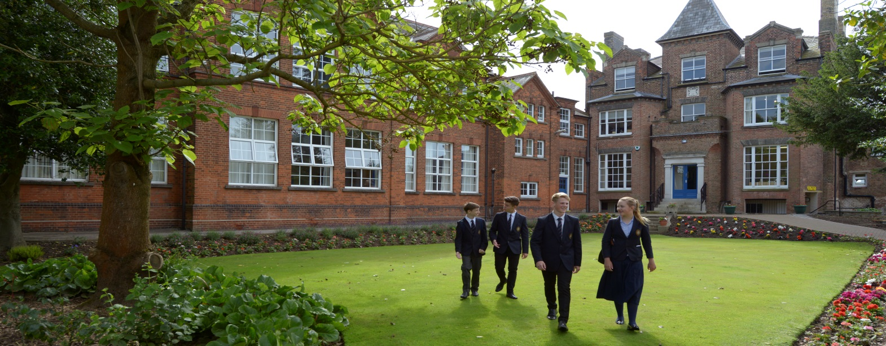

Our Vision

On entering Wisbech Grammar School for the first time you will find more than just a school, we are a community. We are proud to be one of the oldest academically selective HMC day schools in the country but it is what lies beneath the surface which highlights some of the key ingredients which, when brought together, explain why we continue to perform at the highest level when examination results are published. Pass rates are consistently very good and a high percentage of our pupils go on to study at their first choice university. We also successfully send pupils to Oxbridge, Medical, Veterinary, Dentistry school as well as Ivy League universities in America, every year.

Education at Wisbech Grammar is very much seen as a journey and one where each pupil learns to take responsibility for their own learning. We encourage pupils to be involved in all areas of the curriculum and part of our success is undoubtedly due to the commitment of the staff who are more than outstanding teachers. Staff, like the pupils, are involved in teaching, sport, academic and pastoral leadership, clubs and societies.
Pupils at the Prep School, Magdalene House, and the Senior school are positively encouraged to discover and follow their passions. The all-round education offered across the School provides the ideal foundation for fulfilling potential at school, university and beyond.

Wisbech Grammar School achieves very creditable public examination results and has an ambitious and extensive programme of extra-curricular activities. In its sports programme it regularly takes some notable scalps. As a medium-size school it offers high standards of

individualised academic and pastoral care and prides itself on offering a broad based education appealing to a wide range of pupils.

In 2016 our GCSE pass rate was 92% at A* to C with 49% achieving A*/A and at A Level we achieved a 95% pass rate with 55% A*/A/B pass and 77% A-C.

The School is widely recognised as being a good choice for a range of pupils of different abilities, aptitudes and interests. There is a highly experienced team of staff and relationships between pupils and staff are mutually respectful. The community is open, welcoming and genuinely friendly.

Location and Site

The School is situated at the heart of Wisbech on a 34-acre site forming part of the magnificent North Brink which, with the South Brink on the opposite side of the river, was regarded by Pevsner as one of the finest Georgian facades in England. Wisbech itself is a market town at the centre of the Fens and is in a region which is mixed economically and socially and is dominated by agriculture and medium sized light manufacturing enterprises. To the north, King’s Lynn and the many beaches, towns and villages of the north Norfolk Coast are 35 minutes away whilst to the west, Peterborough with its high speed train service to London (47 minutes) is less than 20 miles away. Cambridge, in the south, is about a 40 minute drive by car from Wisbech.

The School’s catchment area is large and growing. There are a number of school bus routes that travel to the School on a daily basis from the local counties of Norfolk, Cambridgeshire and Lincolnshire.

Like its immediate surroundings the School site is attractive. It is maintained to a high standard, with fantastic playing fields and garden areas adding to its appeal. The premises are a mix of the traditional and modern with the more contemporary being purpose-built.

Our Pupil Community
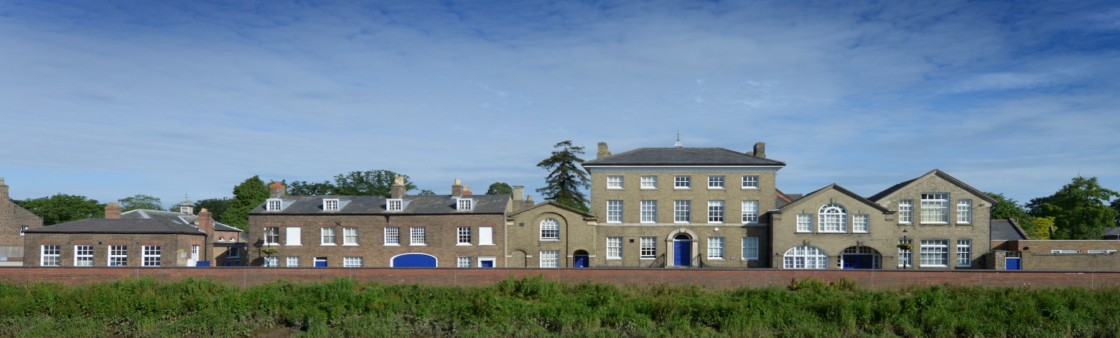
The overall number in the School is around 500, with annual fluctuations. The addition of Magdalene House has been a great success and the roll is robust at approximately 140. A typical number for other year groups is an average of around 60, split evenly between boys and girls. Transfer from Magdalene House to the Senior School is the norm and good examination results help maintain a creditable retention rate from the GCSE year group into the Sixth Form.

Governance and Management

The Governors, as Directors and Trustees, are legally responsible for the overall control of Wisbech Grammar Senior School and Magdalene House. There are currently thirteen on the Board, led by an experienced Chairman, and with a wide range of relevant skills. There are three nominated Governors: one nominated by the Bishop of Ely and two by the Master of Magdalene College, Cambridge. The Board meets formally at least three times a year and operates separate school sub committees. Communication between Governors and the senior team is very good and the Governors take a personal interest in the life of the School well beyond their formal responsibilities.

Our expectations of staff that join us…

Prospective staff joining our school should embrace the opportunity to become part of the Wisbech Grammar School community. You will be expected to teach and inspire our pupils with your subject and demonstrate passion and enthusiasm as you teach. Being part of the School’s co-curricular activities programme is an expected part of your role as might be being a form tutor. Being able to join in with our Sports curriculum and share your sporting expertise would be an added advantage.

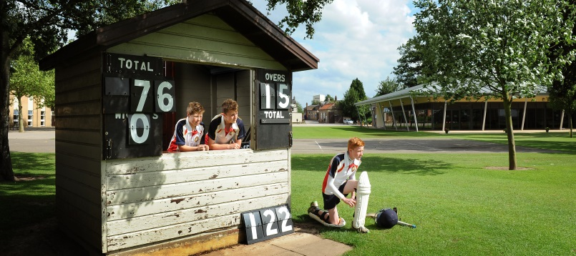

The Benefits of working here

Wisbech Grammar School is a very friendly school with a welcoming Common Room.

The School setting is spacious with an abundance of green and outdoor space creating a great working environment.

Newly Qualified Teaching staff will receive support from their Department Head and our Professional Tutor and all Teaching staff will be able to access our professional review process. Support staff will have a similar programme called ‘ASPIRE’.

The School Governors give a generous remission on fees. (This is subject to the children passing the school entrance assessments and interviews). Remission is offered according to your contract and hours and is at the sole discretion of the Governing Body.

We subscribe to Computershare whereby staff can access benefits which include Childcare Vouchers, Bikes, Health and Wellbeing and Legal benefits.

Building for the Future
At Wisbech Grammar School we always have an eye towards the future. Thinking constantly of how to improve the whole school educational experience for each and every pupil so that every new cohort we welcome into our very special community receives the very best we can offer.

This sometimes manifests itself through new buildings and facilities, such as our wonderful new dining facility, Skelton Hall, which has transformed our provision of breakfasts, lunches and teas. The building is at the heart of our 34 acre campus and like every home the Refectory acts as the heart of our community and is very much a multifunctional and welcoming space.

Looking forward, we have ambitious plans to continue to enhance our teaching and learning through the incorporation of a whole school digital learning strategy which aims to enhance the educational experience for our pupils and teachers.

The key to all our future development is that whatever we build, enhance, redevelop and rejuvenate at Wisbech Grammar School, every decision is taken with children at the centre of decision-making. This chimes with our ethos of providing an all-round education that inspires and prepares our pupils for a world that is developing and changing rapidly.

Next on the development plan is the conversion of the old dining room into a new library and academic resource centre. This will be a whole school resource and will lead to us being able to make concrete plans for a prep-prep department at Wisbech Grammar School.

At the start if the 2016/17 Academic year we changed the shape our school day to ensure that Prep School and Senior School timetables dovetail to ensure the top two years benefit from Senior School (subject teacher) specialists as well as Senior School facilities.

Drama and Music have been established as a Performing Arts faculty in their own right this year and we are looking forward to Dance becoming the final piece of the Performance jigsaw in the near future.

Applying to Wisbech Grammar School
Option 1: Send a speculative application to the school at any time for consideration of any future vacancies – we will hold this on file for you.
Option 2: Application for a specific advertised post. E-mail a letter of application together with our school application and equality form, stating how you fit the role profile, addressed to Mr Chris Staley, Headmaster, for the attention of Mrs Sue Simmons, Human Resources Manager to humanresources@wisbechgrammar.com

Applications by post should be sent to:
Mrs Sue Simmons
Human Resources Manager
Wisbech Grammar School
47 North Brink
Wisbech
PE13 1JX

We look forward to hearing from you.

